**To add Extent report :**

**Step1:** Go to your project------>Right Click------->New------>Folder

------>create folder with Name **src/test/resources**  (If the

folder already exist for you skip Step1)

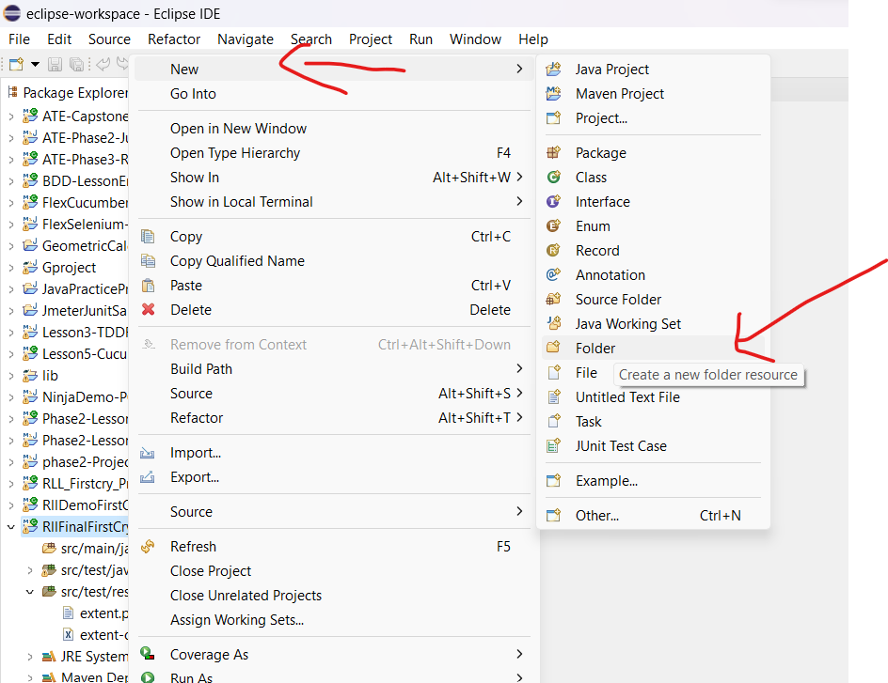

**Step 2:** Go to src/test/ resources ----->RightClick----->New------->File

Create a file with name **extent.properties**

Refer Git hub (I gave the code in Github)

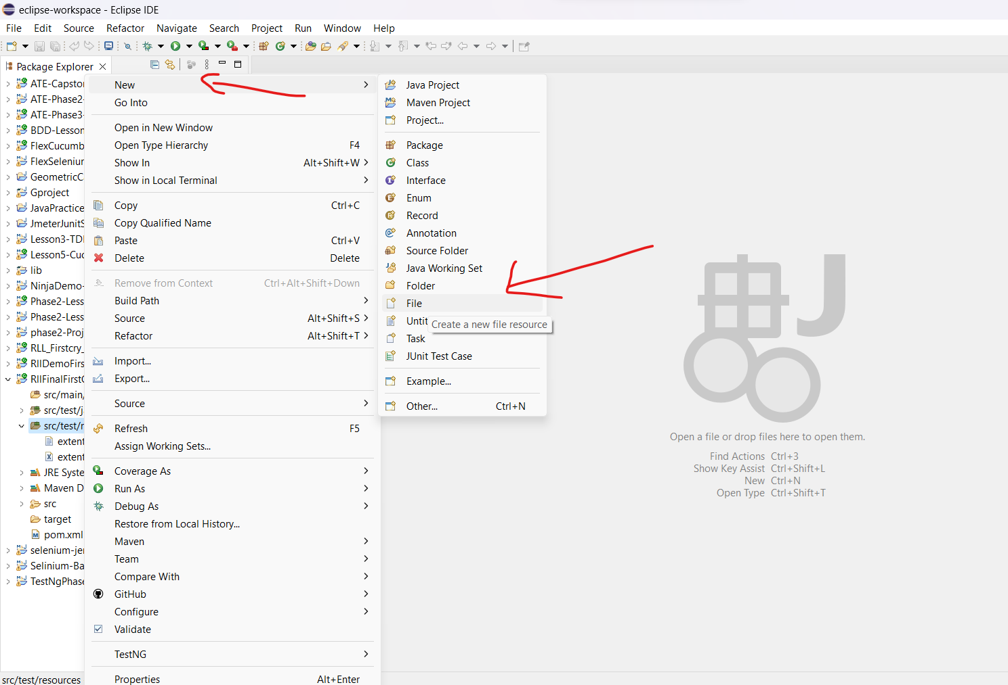

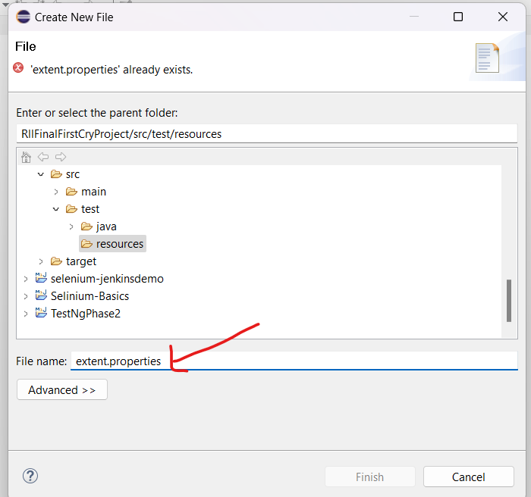

**Step 3:** Go to src/test/ resources ----->RightClick----->New------->File

Create a file with name **extent-config.xml**

Refer Git hub (I gave the code in Github)



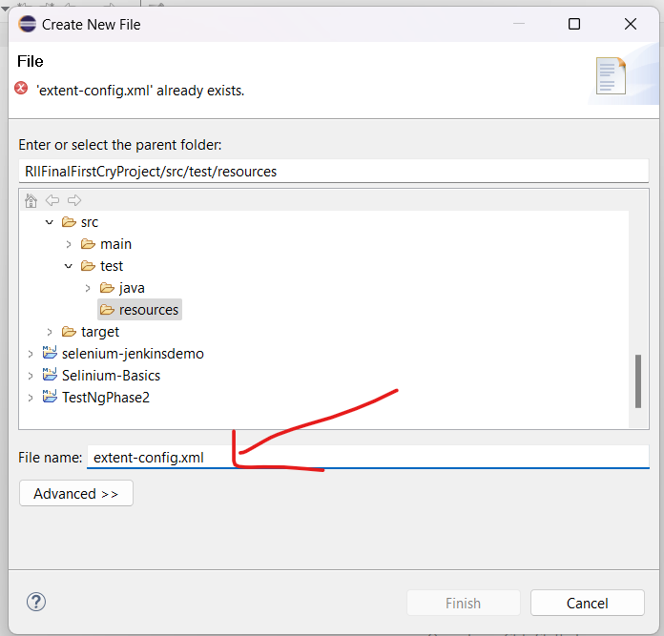

**Step 4:** Add the dependency Il give all the dependency but you

should add the missing dependency in your **POM File**

(I gave dependencies in github also)

<dependencies>

<dependency>

<groupId>junit</groupId>

<artifactId>junit</artifactId>

<version>4.11</version>

<scope>test</scope>

</dependency>

<dependency>

<groupId>io.cucumber</groupId>

<artifactId>cucumber-java</artifactId>

<version>7.10.1</version>

</dependency>

<dependency>

<groupId>org.testng</groupId>

<artifactId>testng</artifactId>

<version>7.7.1</version>

<scope>test</scope>

</dependency>

<!-- https://mvnrepository.com/artifact/io.cucumber/cucumber-java -->

<dependency>

<groupId>io.cucumber</groupId>

<artifactId>cucumber-junit</artifactId>

<version>7.10.1</version>

<scope>compile</scope>

</dependency>

<!-- https://mvnrepository.com/artifact/io.cucumber/cucumber-java -->

<dependency>

<groupId>io.cucumber</groupId>

<artifactId>cucumber-core</artifactId>

<version>7.10.1</version>

</dependency>

<dependency>

<groupId>org.seleniumhq.selenium</groupId>

<artifactId>selenium-java</artifactId>

<version>4.11.0</version>

</dependency>

<!-- https://mvnrepository.com/artifact/io.github.bonigarcia/webdrivermanager -->

<dependency>

<groupId>io.github.bonigarcia</groupId>

<artifactId>webdrivermanager</artifactId>

<version>5.4.1</version>

</dependency>

<dependency>

<groupId>tech.grasshopper</groupId>

<artifactId>extentreports-cucumber7-adapter</artifactId>

<version>1.7.0</version>

</dependency>

<dependency>

<groupId>org.projectlombok</groupId>

<artifactId>lombok</artifactId>

<version>1.18.24</version>

<optional>true</optional>

</dependency>

<!-- https://mvnrepository.com/artifact/io.cucumber/cucumber-picocontainer -->

<dependency>

<groupId>io.cucumber</groupId>

<artifactId>cucumber-picocontainer</artifactId>

<version>7.10.1</version>

</dependency>

</dependencies>

<build>

<pluginManagement><!-- lock down plugins versions to avoid using Maven defaults (may be moved to parent pom) -->

<plugins>

<!-- clean lifecycle, see https://maven.apache.org/ref/current/maven-core/lifecycles.html#clean_Lifecycle -->

<plugin>

<artifactId>maven-clean-plugin</artifactId>

<version>3.1.0</version>

</plugin>

<!-- default lifecycle, jar packaging: see https://maven.apache.org/ref/current/maven-core/default-bindings.html#Plugin_bindings_for_jar_packaging -->

<plugin>

<artifactId>maven-resources-plugin</artifactId>

<version>3.0.2</version>

</plugin>

<plugin>

<artifactId>maven-compiler-plugin</artifactId>

<version>3.8.0</version>

</plugin>

<plugin>

<artifactId>maven-surefire-plugin</artifactId>

<version>2.22.1</version>

<configuration>

<includes>

<include>**/*Runner.java</include>

</includes>

</configuration>

</plugin>

<plugin>

<artifactId>maven-jar-plugin</artifactId>

<version>3.0.2</version>

</plugin>

<plugin>

<artifactId>maven-install-plugin</artifactId>

<version>2.5.2</version>

</plugin>

<plugin>

<artifactId>maven-deploy-plugin</artifactId>

<version>2.8.2</version>

</plugin>

<!-- site lifecycle, see https://maven.apache.org/ref/current/maven-core/lifecycles.html#site_Lifecycle -->

<plugin>

<artifactId>maven-site-plugin</artifactId>

<version>3.7.1</version>

</plugin>

<plugin>

<artifactId>maven-project-info-reports-plugin</artifactId>

<version>3.0.0</version>

</plugin>

</plugins>

</pluginManagement>

</build>

**Step 5:** Create a runner package in your project

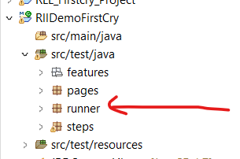

**Step 6:** Right click on Runner package and create a class with name

TestRunner

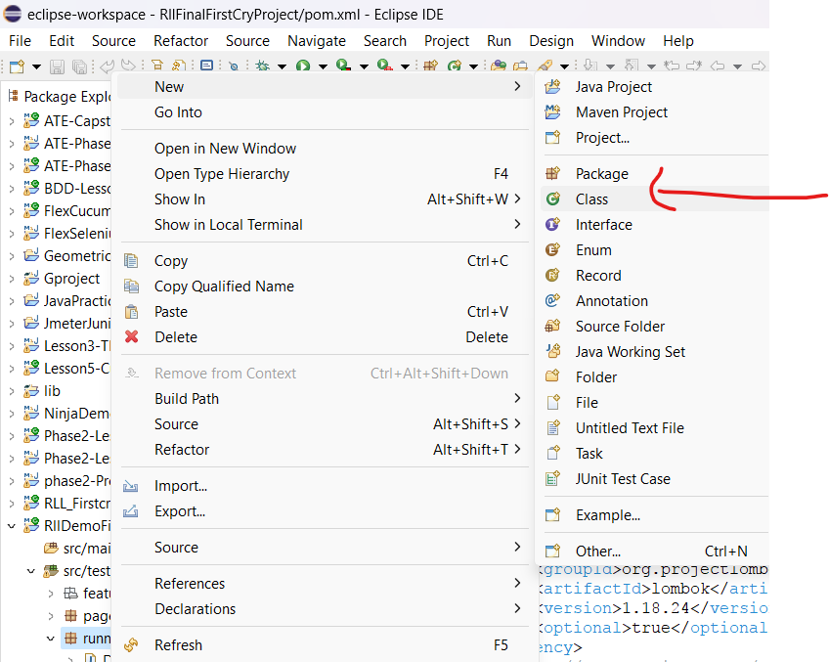

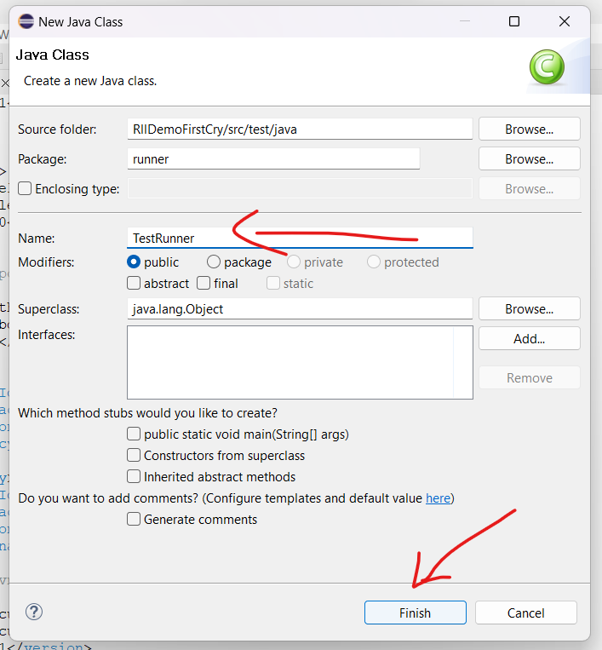

**Step 7:** Add the below code in TestRunner class

Refer Git hub (I gave the code in Github)

And for featurefile (give your feature file location)

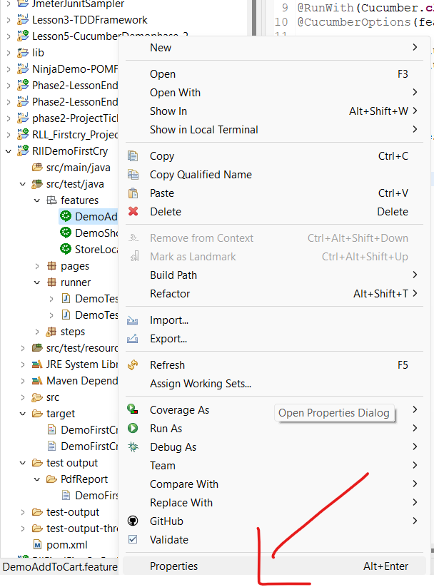

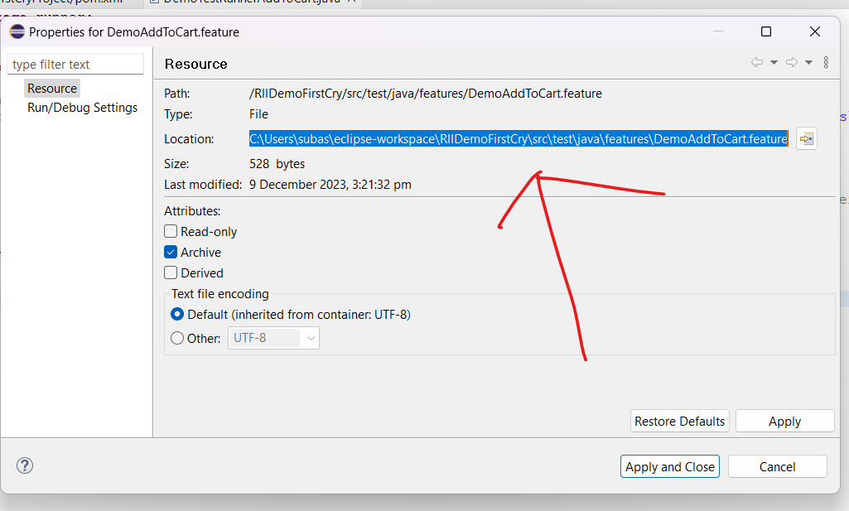

Copy your features file location and paste it in code

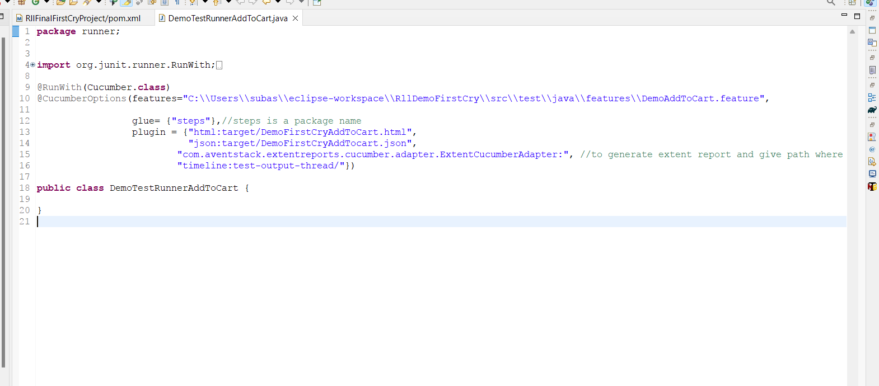

Step 8: Run the file Right click------>Run as Junit Test

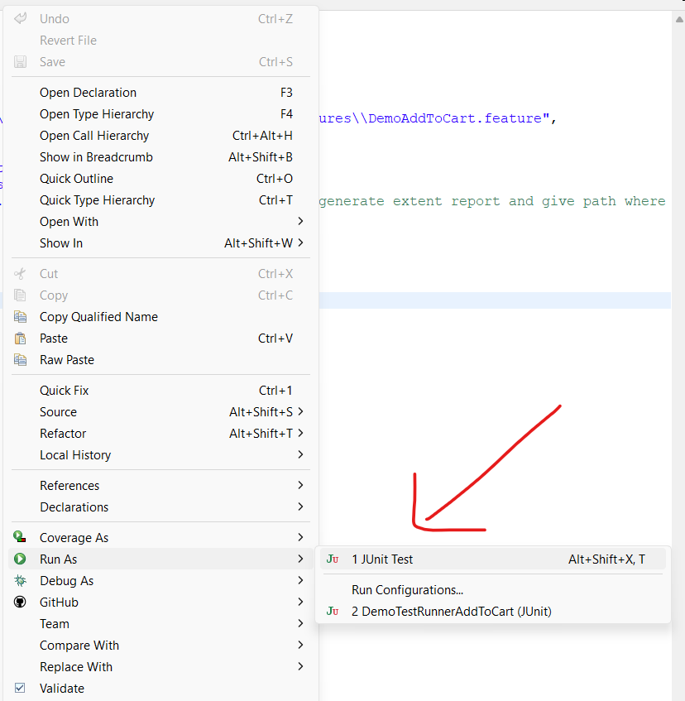

**Step 9:** after running the file refresh your project you ll able to see

the pdf report.html report and json report in target folder

